How to place a conference call at Statler College

**Equipment:**

1. Conference Phone (Analog) … use method A or C  
     
     
     
     
     
     
     
     
     
     
     
     
     
     
     
     
     
     
     
     
     
   ESB 115A/B; MRB 301 ESB 265 ESB G112  
   – good for up to 10 listeners/speakers in room  
   – host plus one (1) remote site … use method A  
   – to get up to six (6) more remote sites need to use VOIP desk phone to setup call … use method C

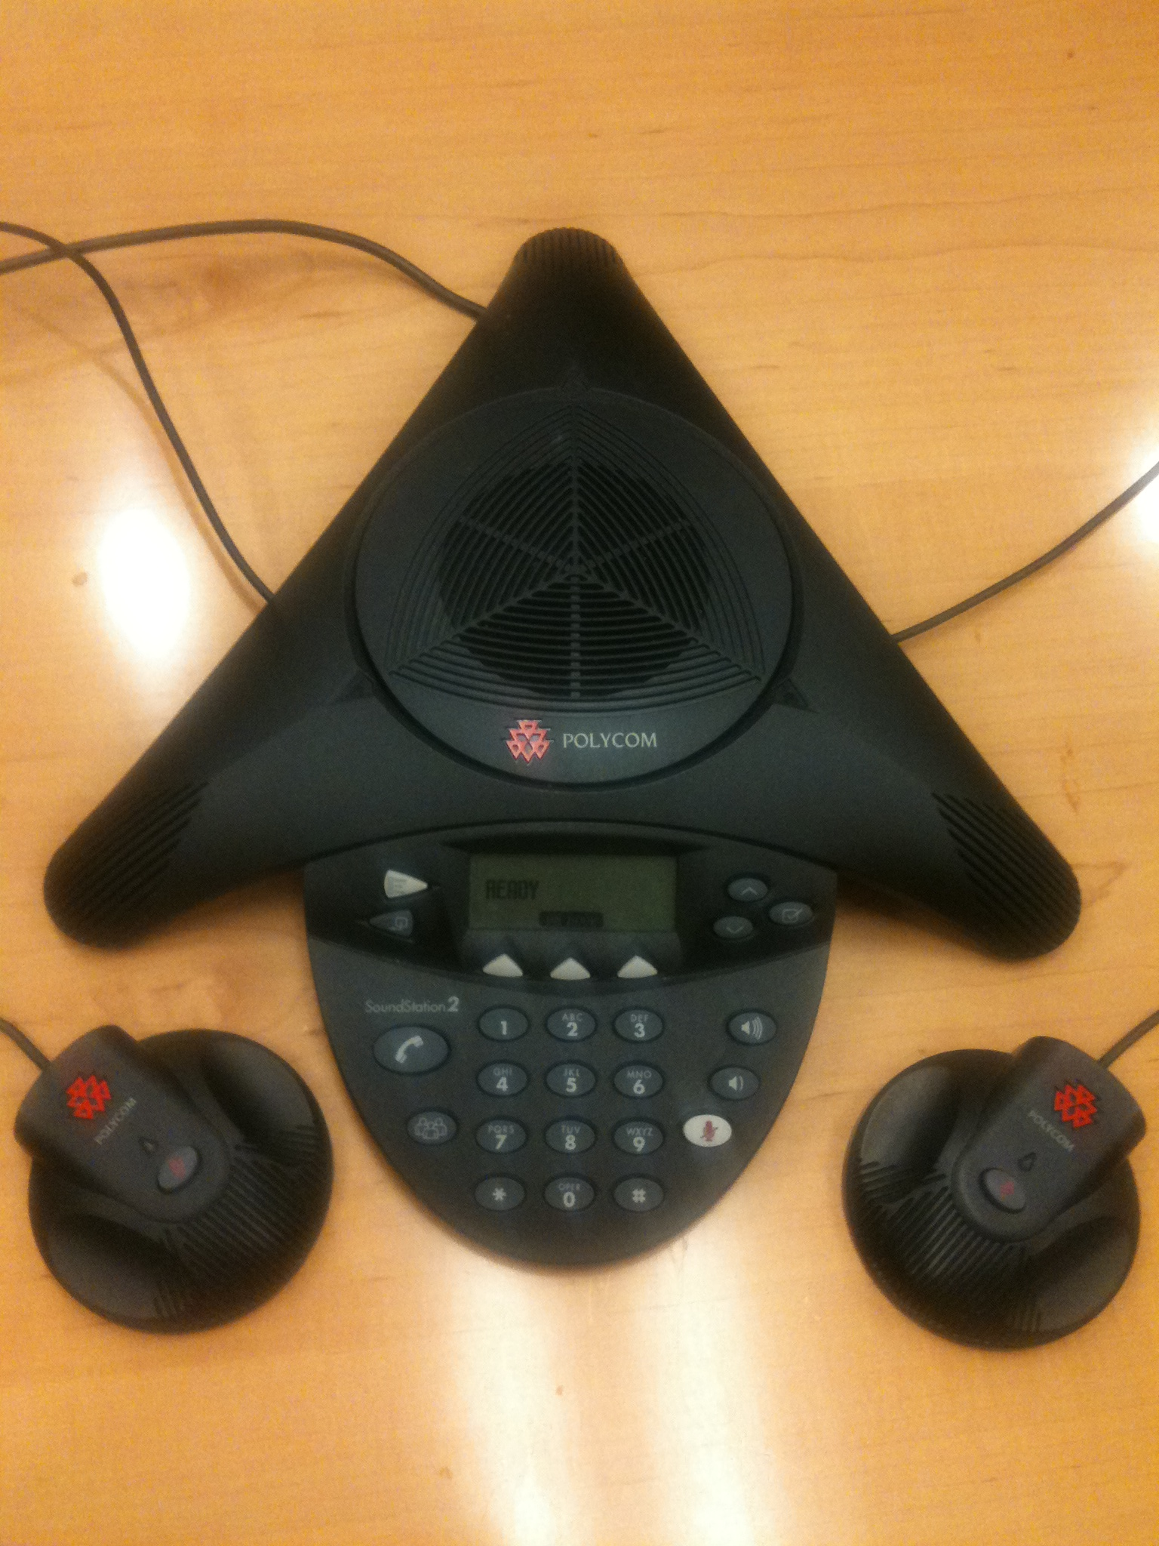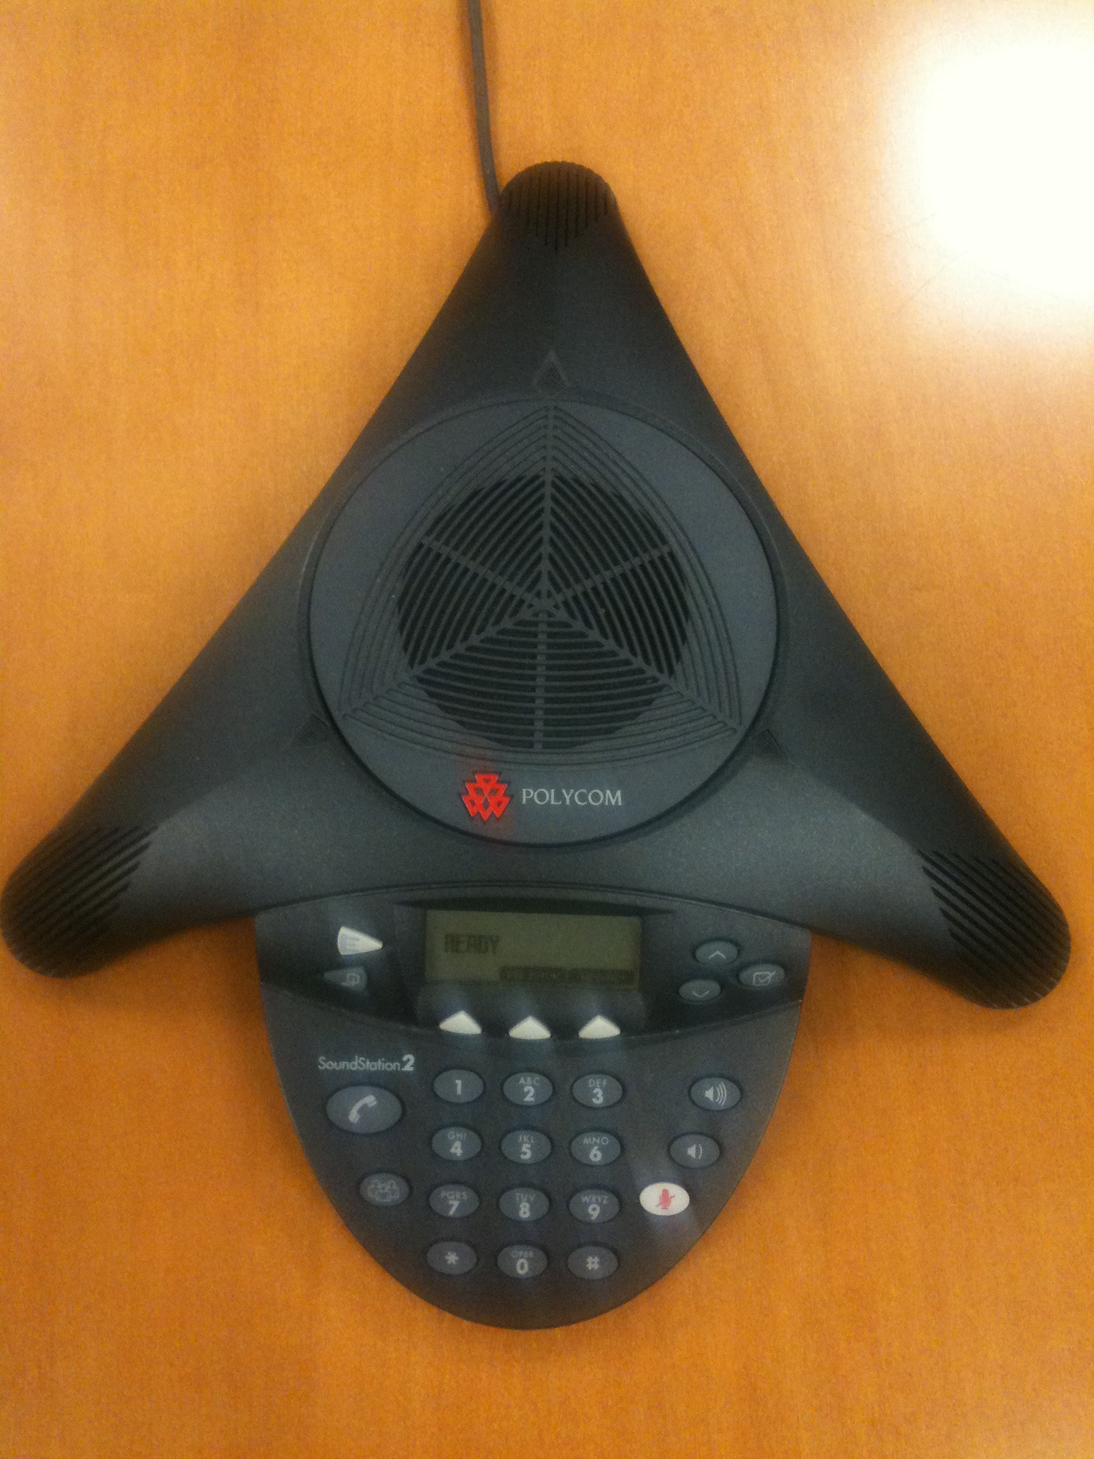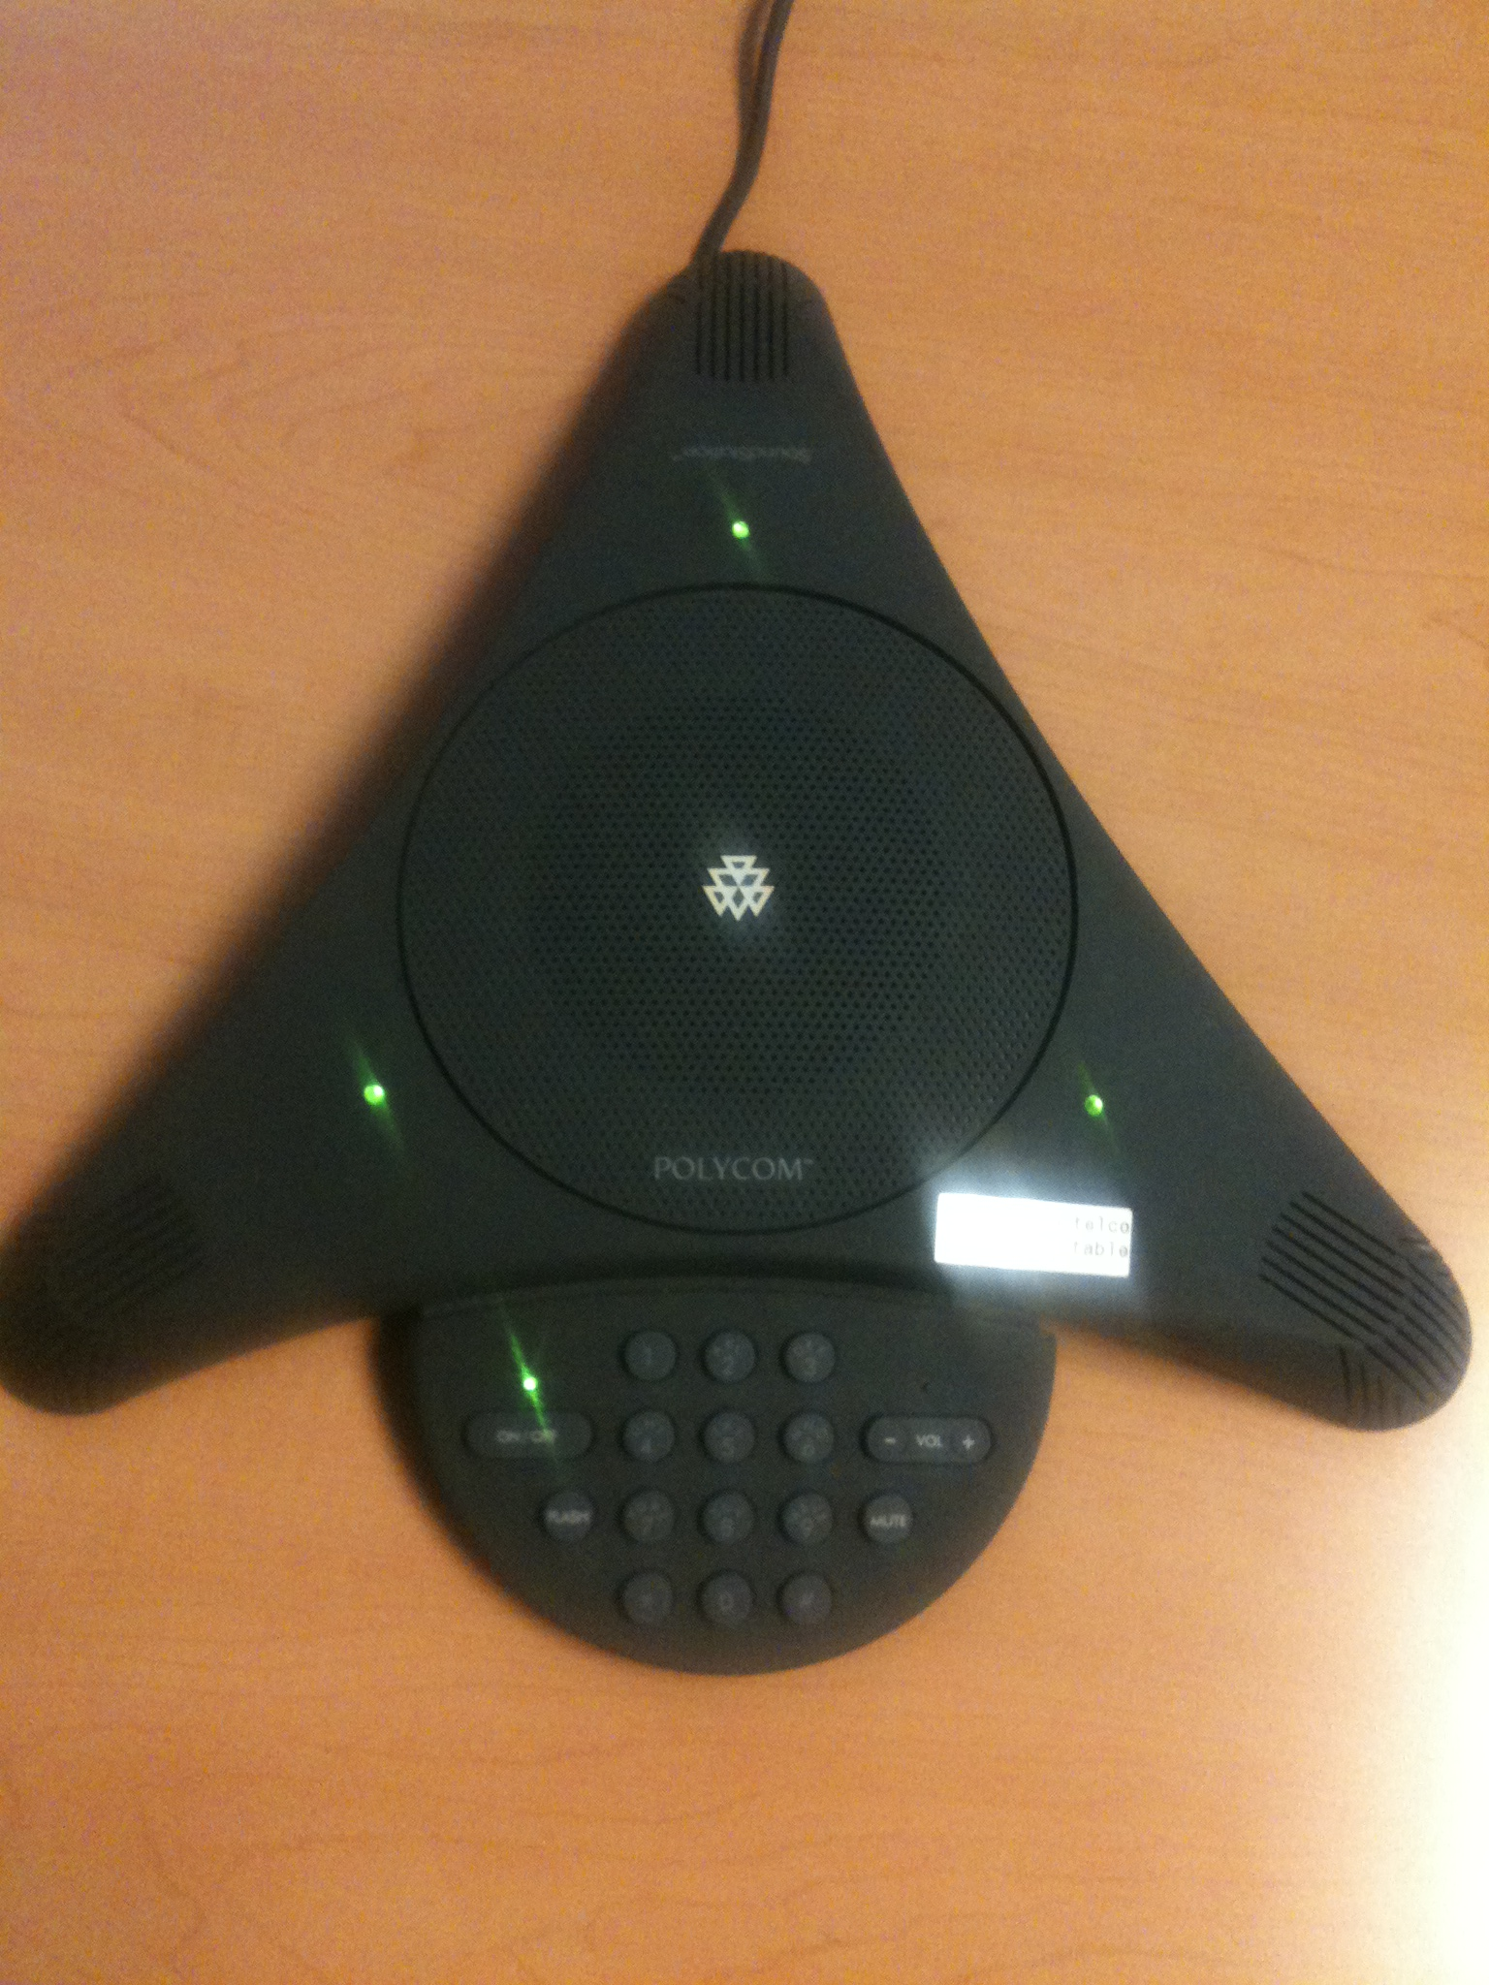

1. Conference Phone (VoIP) … use method B  
     
   **CONFRN**  
      
     
     
   **MORE**  
     
     
     
     
     
     
     
     
     
     
     
     
    ESB 165, 631; MRB 280  
   - good for up to 10 listeners/speakers in room  
   - host plus up to seven (7) remote sites … use method B

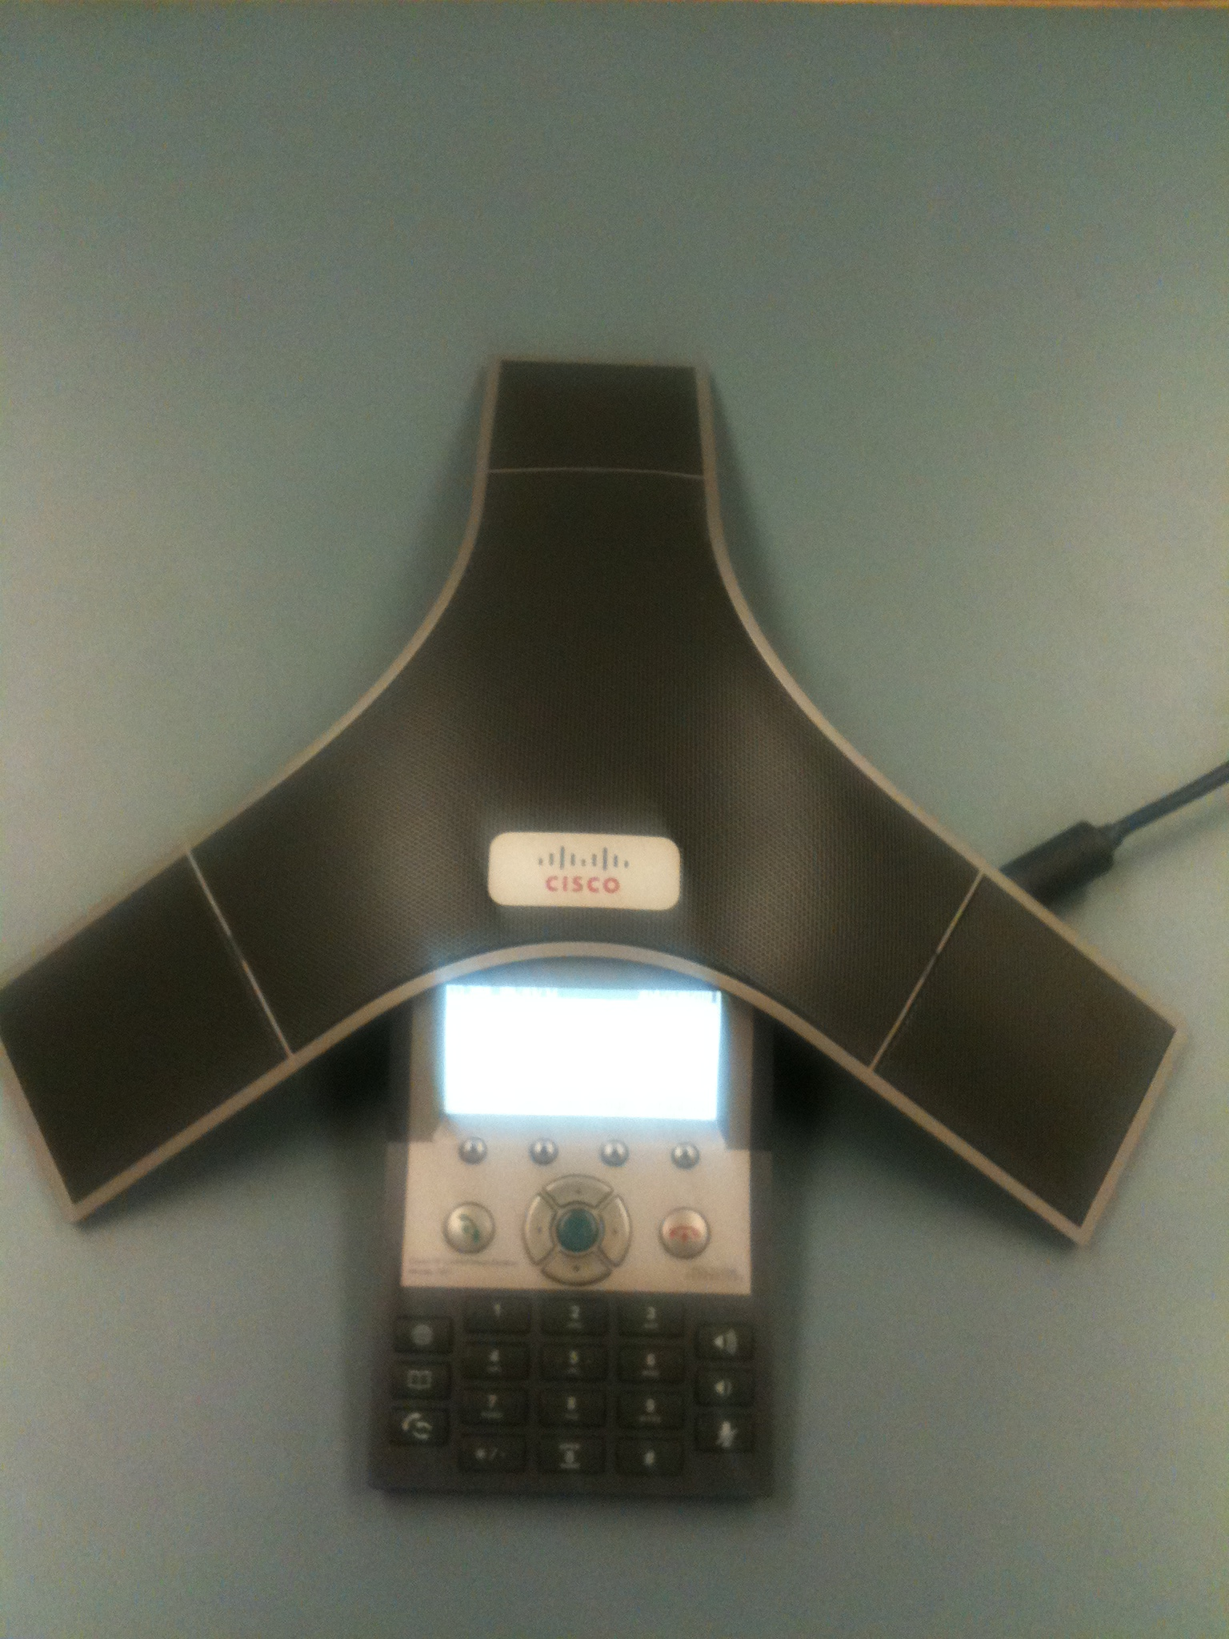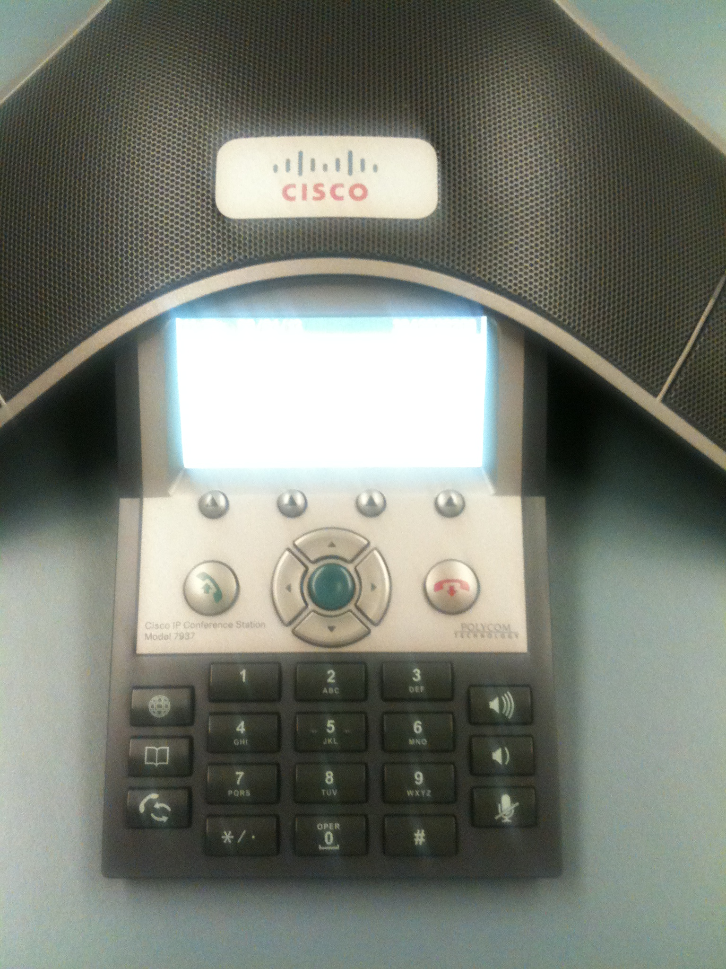

1. Desk Phone with Speakerphone option (VoIP) … use method B  
     
   **CONFRN**  
     
     
     
   **MORE**  
     
     
     
     
     
     
     
   **SPEAKER**  
     
     
     
     
    ERB 214; ESB G64, 104, 153A, 115B, 305, 849; MRB 301  
   - good for up to 4 listeners/speakers in room  
   - host plus up to seven (7) remote sites … use method B

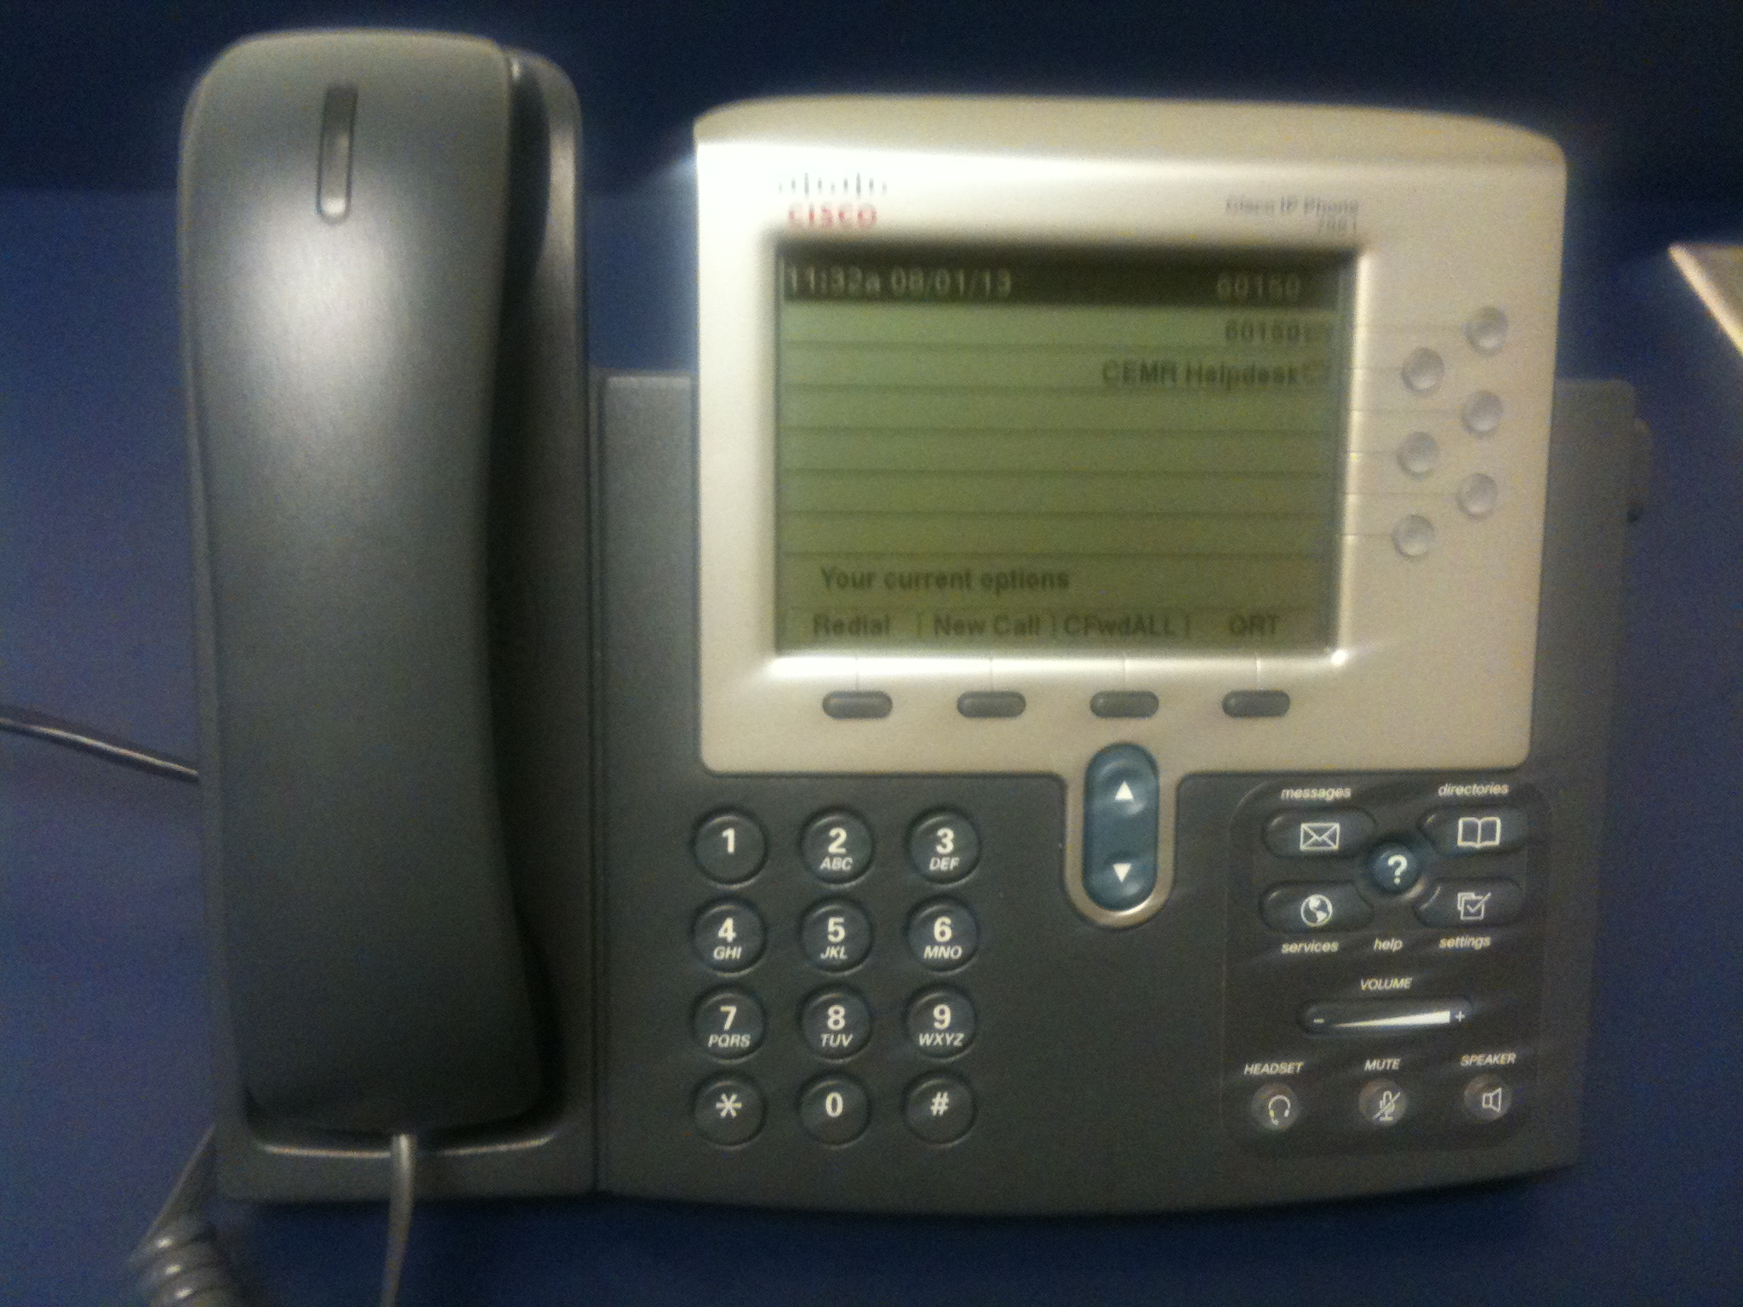

**Notes:**

If you lose a party during the conversation, only method B & C can easily re-establish a site. Use the “**MORE** soft key then **CONFRN** soft key” steps to add remote site back.

Otherwise setup the conference call from scratch.

When gathering information to setup a conference call, follow these basic steps.

1. Contact a representative at each site to set the date, time, phone number, and the name of the site facilitator to be used.
2. Provide a call back number to all sites to avoid frustration if a problem arises. This may be a secretary’s number that is not being used to setup the conference call.
3. Have a valid TID# for long distance calls.

When connecting sites that have more than two people, follow these recommendations to improve the call.

1. Designate a facilitator at each site.
2. Designate a call facilitator.
3. Sites should use mute feature if available, to reduce the distraction of side conversations.
4. Only one person should be talking at a time.

**Useful Phone Numbers to Remember:**

Need help (304) 293-0090 Statler IT Help desk

<http://its.statler.wvu.edu/Statler-Phones>

|  |  |  |
| --- | --- | --- |
| Location | Phone | Type |
| ERB 214 | 304-293-3485 | Desk Phone (VoIP) |
| ESB G64 | 304-293-4311 | Desk Phone (VoIP) |
| ESB G112 | 304-293-7507 | Conference Phone (Analog) |
| ESB 104 | 6-0178 (WVU Only) | Desk Phone (VoIP) |
| ESB 115A/B | 304-293-4295 | Conference Phone (VoIP) |
| ESB 115B | 6-0150 (WVU Only) | Desk Phone (VoIP) |
| ESB 153A | 6-0152 (WVU Only) | Desk Phone (VoIP) |
| ESB 165 | 304-293-7583 | Conference Phone (VoIP) |
| ESB 265 | 304-293-7146 | Conference Phone (Analog) |
| ESB 305 | 304-293-4272 | Desk Phone (VoIP) |
| ESB 631 | 304-293-4243 | Conference Phone (VoIP) |
| ESB 849 | 304-293-0139 | Desk Phone (VoIP) |
| MRB 280 | 304-293-8209 | Conference Phone (VoIP) |
| MRB 301 | 304-293-4283 | Desk Phone (VoIP) |
| MRB 301 | 304-293-4662 | Conference Phone (Analog) |

**How to make a call:**

A. Using “Conference Phone (Analog)” to connect to one (1) remote site  
 Applies to: ESB G112, 115A/B, 265; MRB 301

1. Press ***ON/OFF*** (phone icon) button … see **RED** arrow
2. Dial other site  
   - WVU dial 3 - ####  
   - local dial 9 (###) ### - ####  
   - long distance dial 8 (###) ### - #### wait for long beep and voice then dial TID#  
   - toll free dial 9 (1-800) ### - ####
3. Dial extension as needed
4. Greet other site and begin conversation
5. Press ***ON/OFF*** (phone icon) button to end call

B. Using “Conference/Desk Phone (VoIP)” to connect up to seven (7) remote sites  
 Applies to:   
 Conference Phone …ESB 165, 631; MRB 280  
 Desk Phone …ERB 214; ESB G64, 104, 153A, 115B, 305, 849; MRB 301

1. Press **GREEN** phone button (conference phone) or **SPEAKER** button (desk phone) … see **RED** arrow
2. Dial other site  
   - WVU dial 3 - ####  
   - local dial 9 (###) ### - ####  
   - long distance dial 8 (###) ### - #### wait for long beep and voice then dial TID#  
   - toll free dial 9 (1-800) ### - ####
3. Dial extension as needed
4. Greet other site and begin conversation

***Announce a conference call is being setup. Say “Please wait a moment while I connect the next site. If I lose you, hang up and I will call again.”***

**… to add more remote sites, continue below …**

1. Press the **MORE** soft key then **CONFRN** soft key

repeat steps 2-4 … AND press **CONFRN** soft key to add remote to group  
 **… to end call, continue below …**

1. Press **RED** phone button (conference phone) or **SPEAKER** button (desk phone) to end the call

**!!! Make sure all parties have disconnected first, to avoid extra charges. !!!**

**How to make a call (continued):**

C. Using “Desk Phone (VoIP)” with “Conference Phone (Analog)” to connect up to six (6) remote sites  
 Applies to: ESB G112, 115A/B, 265; MRB 301

1. Starting with a Desk Phone (VoIP)  
   … Press **SPEAKER** button (desk phone) … see **RED** arrow
2. Dial the “Conference Phone (Analog)” … REMOTE #1  
   ESB G112 … 3-7507  
   ESB 115A/B … 3-4295  
   MRB 301 … 3-4662
3. Answer call on “Conference Phone (Analog)”, press ***ON/OFF*** (phone icon) button … see **RED** arrow
4. Greet conference room group

**…to add remote sites #2 thru #7, continue below with DESK PHONE**

1. Press the **MORE** soft key then **CONFRN** soft key
2. Dial other site  
   - WVU dial 3 - ####  
   - local dial 9 (###) ### - ####  
   - long distance dial 8 (###) ### - #### wait for long beep and voice then dial TID#  
   - toll free dial 9 (1-800) ### - ####
3. Dial extension as needed
4. Greet other site and begin conversation

***Announce a conference call is being setup. Say “Please wait a moment while I connect the next site. If I lose you, hang up and I will call again.”***

1. Press **CONFRN** soft key to add remote to group
2. Repeat steps 5-9
3. Once all sites are connected, place DESK PHONE on HOLD  
     
   **… to end call, continue below …**
4. Press ***ON/OFF*** (phone icon) button (on conference phone) to end call  
   **!!! Make sure all parties have disconnected first, to avoid extra charges. !!!**
5. Line on HOLD should release automatically (desk phone) to end the call